**Constituency Connect**



**Project Members:**

Muhammad Ahsan

21-ARID-737

Haseeb Ur Rehman

21-ARID-715

Huzaifa Bin Shahzad

21-ARID-719

**Course:**

Software Project Management (SPM)

**Assignment:**

Assignment# 2

**Submitted to:**

Sir Ahsan

**Work Breakdown Structure (WBS):**

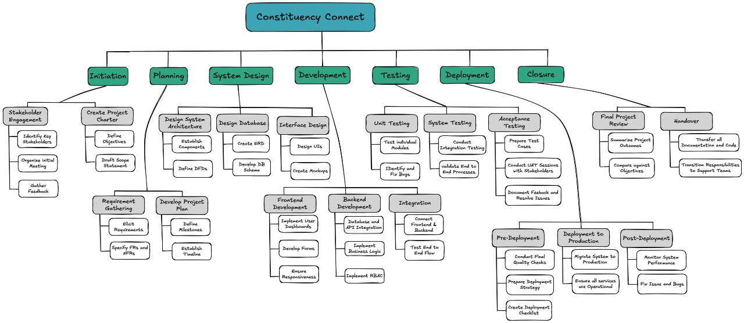

**Outline:**

1. Constituency Connect

1.1 Initiation

1.1.1 Stakeholder Engagement

* + Identify Key Stakeholders
  + Organize Initial Meeting
  + Gather Feedback

1.1.2 Create Project Charter

* + Define Objectives
  + Draft Scope Statement

1.1.3 Requirement Gathering

* + Elicit Requirements
  + Specify Functional and Non-Functional Requirements (FRs and NFRs)

1.2 Planning

1.2.1 Develop Project Plan

* + Define Milestones
  + Establish Timeline

1.3 System Design

1.3.1 Design System Architecture

* + Establish Components
  + Define DFDs

1.3.2 Design Database

* + Create ERD
  + Develop DB Schema

1.3.3 Interface Design

* + Design UIs
  + Create Mockups

1.4 Development

1.4.1 Frontend Development

* + Implement User Dashboards
  + Develop Forms
  + Ensure Responsiveness

1.4.2 Backend Development

* + Database and API Integration
  + Implement Business Logic
  + Implement Role-Based Access Control (RBAC)

1.4.3 Integration

* + Connect Frontend & Backend
  + Test End-to-End Flow

1.5 Testing

1.5.1 Unit Testing

* + Test Individual Modules
  + Identify and Fix Bugs

1.5.2 System Testing

* + Conduct Integration Testing
  + Validate End-to-End Processes

1.5.3 Acceptance Testing

* + Prepare Test Cases
  + Conduct UAT Sessions with Stakeholders
  + Document Feedback and Resolve Issues

1.6 Deployment

1.6.1 Pre-Deployment

* + Conduct Final Quality Checks
  + Prepare Deployment Strategy
  + Create Deployment Checklist

1.6.2 Deployment to Production

* + Migrate System to Production
  + Ensure All Services Are Operational

1.6.3 Post-Deployment

* + Monitor System Performance
  + Fix Issues and Bugs

1.7 Closure

1.7.1 Final Project Review

* + Summarize Project Outcomes
  + Compare Against Objectives

1.7.2 Handover

* + Transfer All Documentation and Code
  + Transition Responsibilities to Support Teams

**Gantt Chart:**

